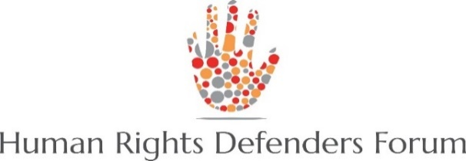
Rights for All

Joint Statement
The Statement of Myanmar Human Rights Defenders Against the killing of Karen environmentalist

11th April 2018
The Human Rights Defender Forum (HRDF) and the consortium partners of “Rights for All” are saddened to learn that one of the members of Karen Environmental and Social Network was reportedly shot dead by the Tatmadaw in Ler Mu Plaw Region, Kayin State on April 5th 2018.
Saw O Moo is the environmentalist as well as a human rights defender who is actively working for the environmental issue. Since 2006, he has worked for the Karen Environmental and Social Action Network as a local community partner. He is also an active member of Salween Peace Park Committee and Peace, Biodiversity conservation and Cultural preservation.
Promoting to conserve the environment is also protecting of human rights. The human rights defenders (HRDs) are the one who promote and protect all human rights in non-violent ways and act without discrimination. For the safety and promoting role of Human Rights Defenders, the United Nations has adopted Declaration of Human Rights Defenders and their family members on 9th December, 1998.
The killing of Karen peace and environmentalist advocate, Saw O Moo, has been proved that there is no protection and security for the HRDs for those who are working for safeguarding human rights particularly in the conflict affected areas where the fighting is ongoing.
Threatening to a single HRD is also a kind of threatening to all human beings who fully deserve the human rights. Thus, United Nations Declaration on Human Rights Defenders clearly stated the obligation of government and international community to protect human rights defender as they are the one who promote and protect human rights and human dignity of all human.
Therefore, The Human Rights Defender Forum and the Rights for All consortium partners would like to strongly urge to the Myanmar Government to protect effectively and to the ethnic HRDs particularly from the conflict areas.
For more information, please contact,
U Aung Myo Min, Executive Director, Equality Myanmar: 09 448015306
U Aung Zaw Oo, Chairman of Human Rights Defender Forum (HRDF): 09 421039493
Htoo Kyaw Win, Coordinator of Human Rights Defender Forum (HRDF): 09 794380895

- Human Rights Defender Forum is the network which aims to improve the coordination and communication of all Myanmar human rights defenders. The network is established in July 2014 comprising of ten Human Rights NGOs, four human rights INGO, and two individuals.

- “Rights for All” aims to strengthen Human Rights Defenders (HRDs) and civil society efforts in promoting and protecting human rights of vulnerable and marginalized groups and enhance their influence in policy dialogue to create a more inclusive and sustainable democratic society in Myanmar. “Rights for All” is the consortium initiative between Equality Myanmar (EQMM), Local Resource Center (LRC), DCA/NCA established in 2017 with a member of more than 550 HRDs/CA in six ethnic regions.

